**SOFTWARE REQUIREMENTS SPECIFICATION**

**ONLINE MARKET WEB APPLICATION**

**Author:** Athidya U

**Version:** 1.0

**Date:** April 06, 2024

**TABLE OF CONTENT**

|  |  |
| --- | --- |
| **ABSTRACT** | **3** |
| **REQUIREMENTS**   * **FUNCTIONAL REQUIREMENT** * **NON-FUNCTIONAL REQUIREMENT** | **3**  **4**  **5** |
| **TECH STACK** | **6** |
| **FLOWCHART** | **7** |
| **USECASE DIAGRAM** | **9** |
| **CLASS DIAGRAM** | **10** |
| **SEQUENCE DIAGRAM** | **11** |
| **UI/UX DESIGN** | **12** |
| **TESTCASES & TESTING** | **15** |
| **LINKS** | **16** |

**ABSTRACT**

Online market aims to revolutionize the grocery shopping experience by connecting consumers directly with farmers and vendors, cutting out the middlemen to ensure affordability and superior quality. Through this platform, consumers gain access to a diverse array of fresh produce and grocery items sourced directly from local producers. By circumventing traditional supply chains, the system not only ensures fair compensation for farmers and vendors but also offers competitive prices for consumers, making high-quality goods more accessible to a wider audience. Rigorous quality control measures are implemented to guarantee the freshness and integrity of all products, instilling trust and confidence in the minds of consumers.

Furthermore, the platform's user-friendly interface streamlines the shopping process, allowing customers to browse, order, and pay for items with ease. Flexible delivery options further enhance convenience, accommodating varying schedules and preferences. Beyond its practical benefits, the online market fosters a sense of community by facilitating direct interactions between consumers and producers, encouraging sustainable practices, and supporting local economies. By prioritizing transparency, affordability, and sustainability, this initiative represents a fundamental shift towards a more equitable and resilient food system, benefiting both consumers and producers alike.

In addition to providing a seamless shopping experience and fostering community connections, the online market serves as a catalyst for promoting healthier lifestyles and sustainable food consumption practices. By offering a wide range of fresh, locally sourced products, the platform encourages consumers to make informed choices about their diet and nutrition. Through educational initiatives and transparent information about farming practices, consumers gain a deeper appreciation for the origins of their food and the efforts involved in its production. Moreover, by directly supporting local farmers and vendors, the platform contributes to the resilience of regional food systems, reducing reliance on large-scale industrial agriculture and mitigating the environmental impact associated with long-distance transportation and mass production. Ultimately, the online market represents a transformative force in the realm of grocery retail, empowering individuals to make conscious, ethical decisions while fostering economic vitality and environmental stewardship within their communities.

**REQUIREMENTS**

For the successful implementation of the online market project, several key requirements must be addressed comprehensively. Firstly, a robust and secure online platform must be developed, capable of facilitating seamless interactions between consumers, farmers, and vendors. This platform should feature intuitive user interfaces for browsing products, placing orders, and making payments, ensuring a user-friendly experience for all users. This system must incorporate a comprehensive product management module, allowing farmers and vendors to easily upload, update, and manage their inventory. Integration with payment gateways and logistics services is essential for processing transactions and coordinating timely deliveries. Moreover, stringent quality control measures must be implemented to verify the freshness and quality of all products sold on the platform, thereby instilling trust and confidence among consumers.

**FUNCTIONAL REQUIREMENTS**

Functional requirements for the online market project encompass the core functionalities and features that the system must possess to fulfil its intended purpose. These requirements can be outlined as follows:

* User Registration and Authentication: Users should be able to create accounts, log in securely, and manage their profiles. This includes features like password reset and account recovery mechanisms.
* Product Catalogue Management: Farmers and vendors should have the ability to upload, update, and remove their products from the platform. This involves categorizing products, adding descriptions, and specifying quantities and prices.
* Browsing and Searching: Users should be able to browse products by category, filter search results based on various criteria (e.g., price, availability), and view detailed product information.
* Shopping Cart and Checkout: Users should be able to add items to their shopping carts, review their selections, and proceed to checkout. The checkout process should support multiple payment methods and provide order confirmation upon completion.
* Order Management: The system should enable users to track the status of their orders, receive notifications regarding order updates (e.g., order confirmation, delivery status), and manage their order history.
* Quality Assurance and Feedback: The platform should incorporate mechanisms for ensuring the quality and authenticity of products. Users should be able to provide feedback and ratings for products and sellers, helping to maintain transparency and trust.
* Delivery and Logistics Integration: Integration with logistics services is necessary to facilitate order fulfilment and delivery. This includes features like address verification, order scheduling, and real-time tracking of deliveries.
* Customer Support and Communication: The system should provide channels for users to contact customer support, seek assistance with orders, and receive timely responses to inquiries. This may include live chat, email support, or helpdesk functionality.
* Promotions and Discounts: The platform should support promotional campaigns, discount codes, and special offers to incentivize purchases and attract customers.
* Reporting and Analytics: Administrative features should include reporting tools and analytics dashboards for monitoring sales performance, inventory levels, and user engagement metrics.
* Accessibility and Localization: The platform should be accessible to users with disabilities and support multiple languages and currencies to cater to diverse audiences.

These functional requirements form the foundation of the online market project, outlining the essential features and capabilities needed to create a seamless and satisfying shopping experience for users while supporting the operations of farmers and vendors.

**NON-FUNCTIONAL REQUIREMENTS**

Non-functional requirements describe the attributes that define the system's operation and quality characteristics rather than specific behaviours. For the online market project, several non-functional requirements are crucial for ensuring the platform's performance, security, usability, and scalability. These may include:

* Performance: The system should be responsive and capable of handling concurrent user interactions without significant delays. Response times for actions like page loading, search queries, and checkout processes should be optimized to enhance user experience.
* Scalability: The platform should be designed to accommodate increasing numbers of users and products over time without compromising performance. This includes scalability in terms of both hardware infrastructure and software architecture.
* Reliability: The system should be highly reliable, minimizing downtime and ensuring uninterrupted access to services. This may involve implementing redundant systems, failover mechanisms, and automated backups to mitigate the risk of system failures.
* Security: Security measures should be implemented to protect user data, financial transactions, and sensitive information from unauthorized access, manipulation, or breaches. This includes encryption protocols, secure authentication mechanisms, and compliance with data protection regulations.
* Usability and Accessibility: The platform should be intuitive and easy to use, with a user-friendly interface that accommodates users of varying technical proficiency. Additionally, the system should adhere to accessibility standards to ensure usability for individuals with disabilities.
* Compatibility: The platform should be compatible with a wide range of devices, browsers, and operating systems to ensure seamless access for users regardless of their preferred technology environment.
* Maintainability: The system should be designed with modularity and extensibility in mind, allowing for easy maintenance, updates, and enhancements over time. Clean code practices, documentation, and version control systems should be utilized to facilitate ongoing development and maintenance.
* Compliance: The platform should comply with relevant industry standards, regulations, and best practices, including those related to data privacy, consumer protection, and e-commerce regulations.
* Performance Monitoring and Logging: Monitoring tools should be in place to track system performance, detect anomalies, and identify areas for optimization. Comprehensive logging mechanisms should also be implemented to record system activities and facilitate troubleshooting.

**TECH STACK**

**Front end:**

* HTML5
* CSS3
* React JS
  + Axios
  + React-router-dom
  + React-cookie

**Back end:**

* Express JS
* Node JS

**Source control:**

* Git
* GitHub

**Database:**

* MySQL

**UI Designing:**

* Figma

**Implementation:**

* VScode

**Testing:**

* Postman

**System specification:**

* OS: Windows / Linux (Debian, Arch preferrable)
* Minimum RAM: 4GB (For expected smooth performance)
* Zoom size: 100%
* Resolution: 1920x1080 or above
* Developed browser: Mozilla Firefox (developer edition)

**FLOWCHART**

**Users Flowchart**

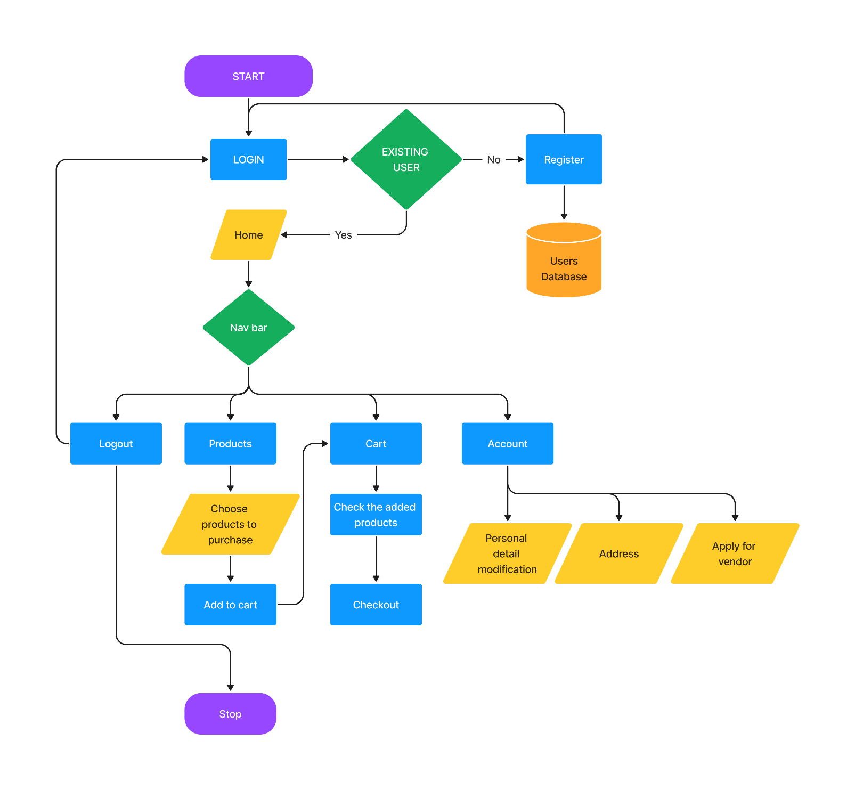

Fig 1: Users Flowchart

**Vendor Flowchart**

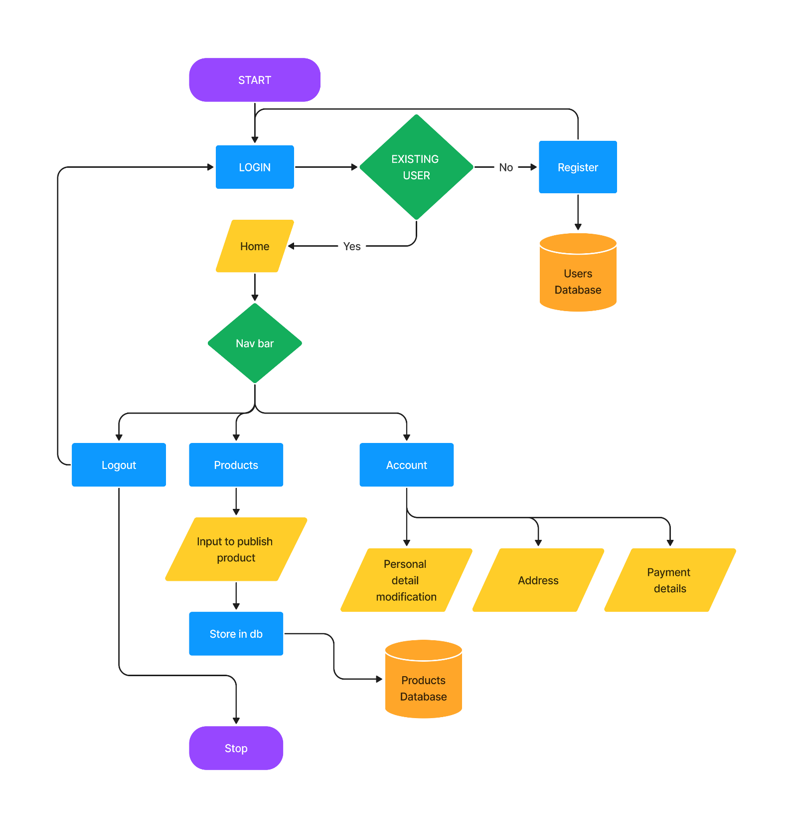

Fig 2: Vendor Flowchart

**USE CASE DIAGRAM**

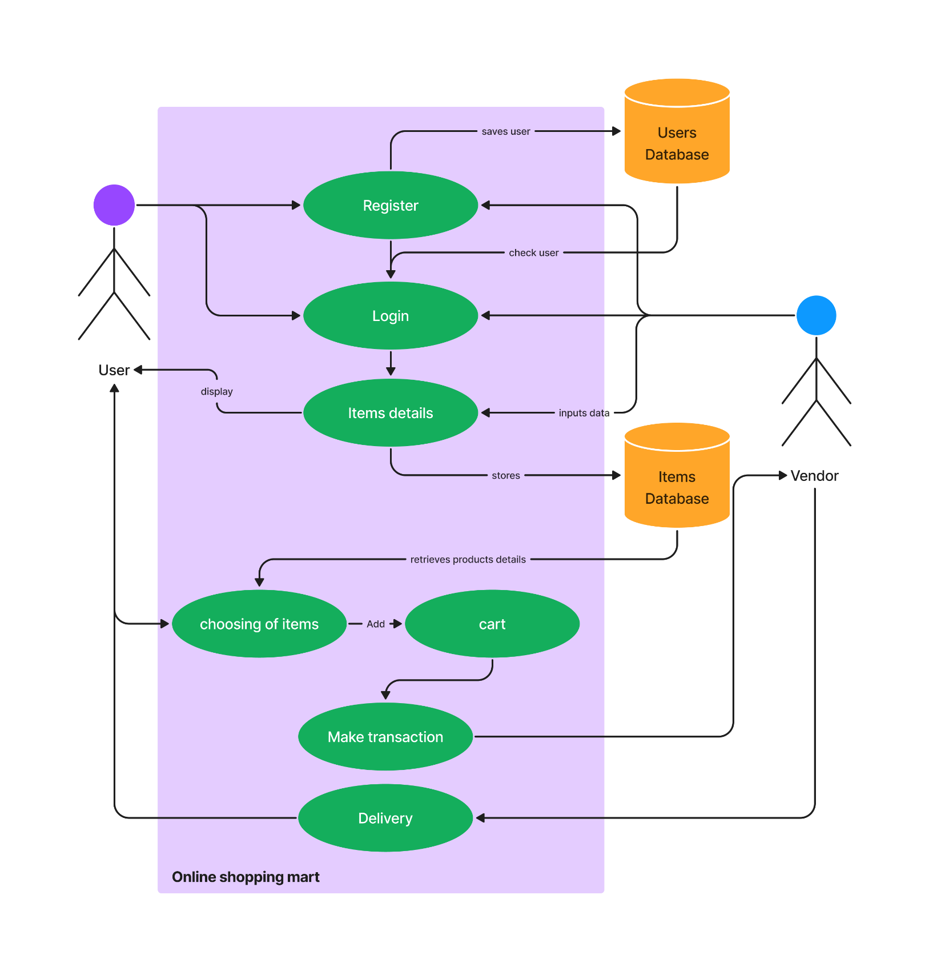

Fig 3: Use Case diagram of online market

**CLASS DIAGRAM**

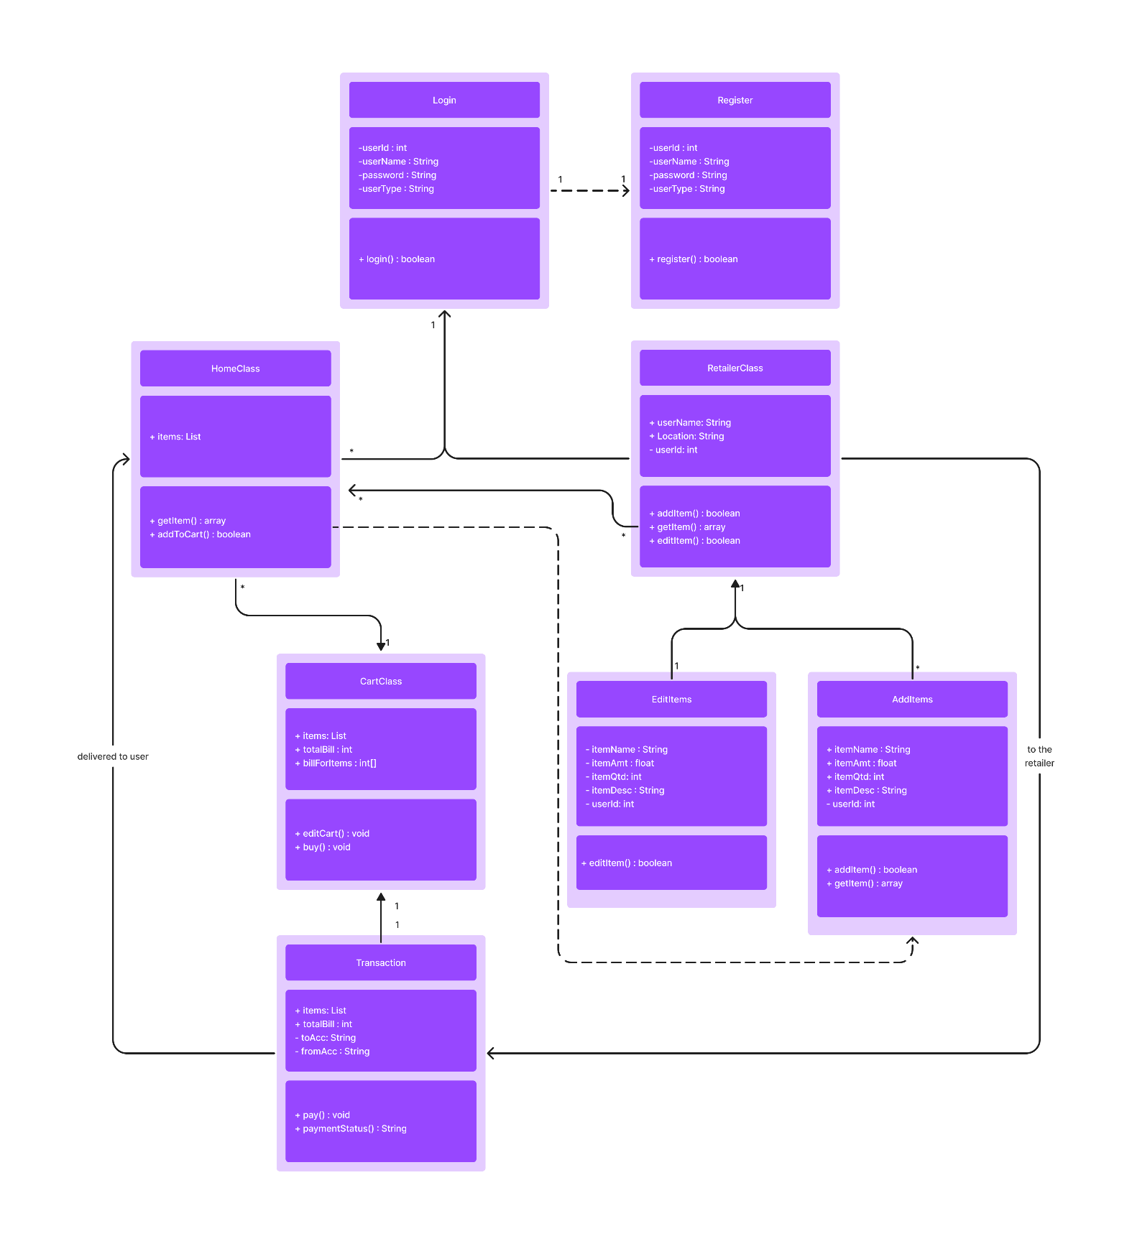

Fig 4: Class diagram of online market

**SEQUENCE DIAGAM**

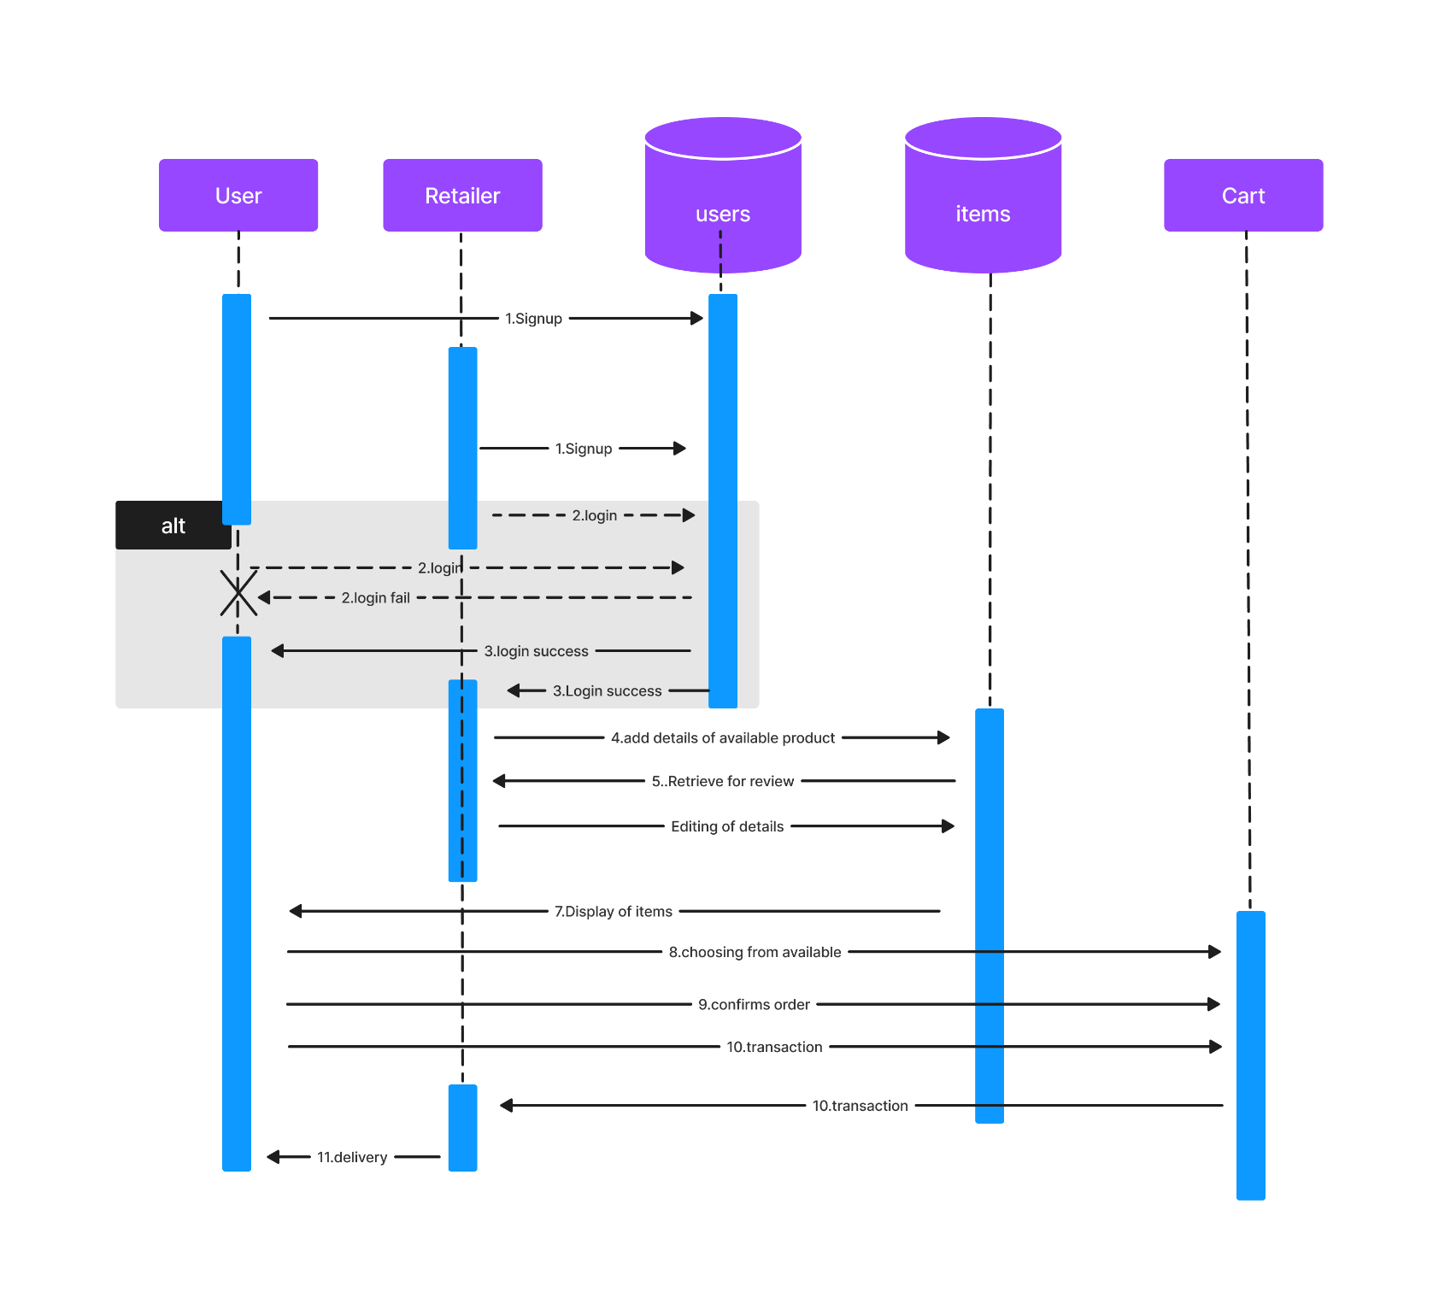

Fig 5: Sequence diagram

**UI/ UX DESIGN**

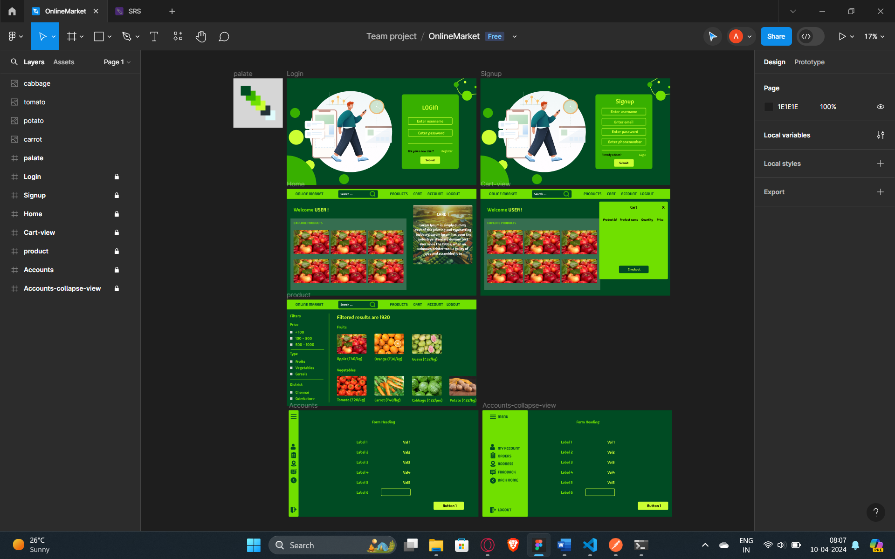

Fig 6: Designing in Figma

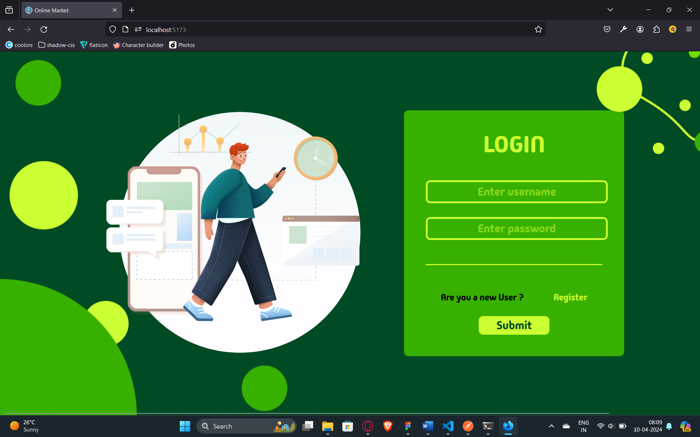

Fig 7: Login page

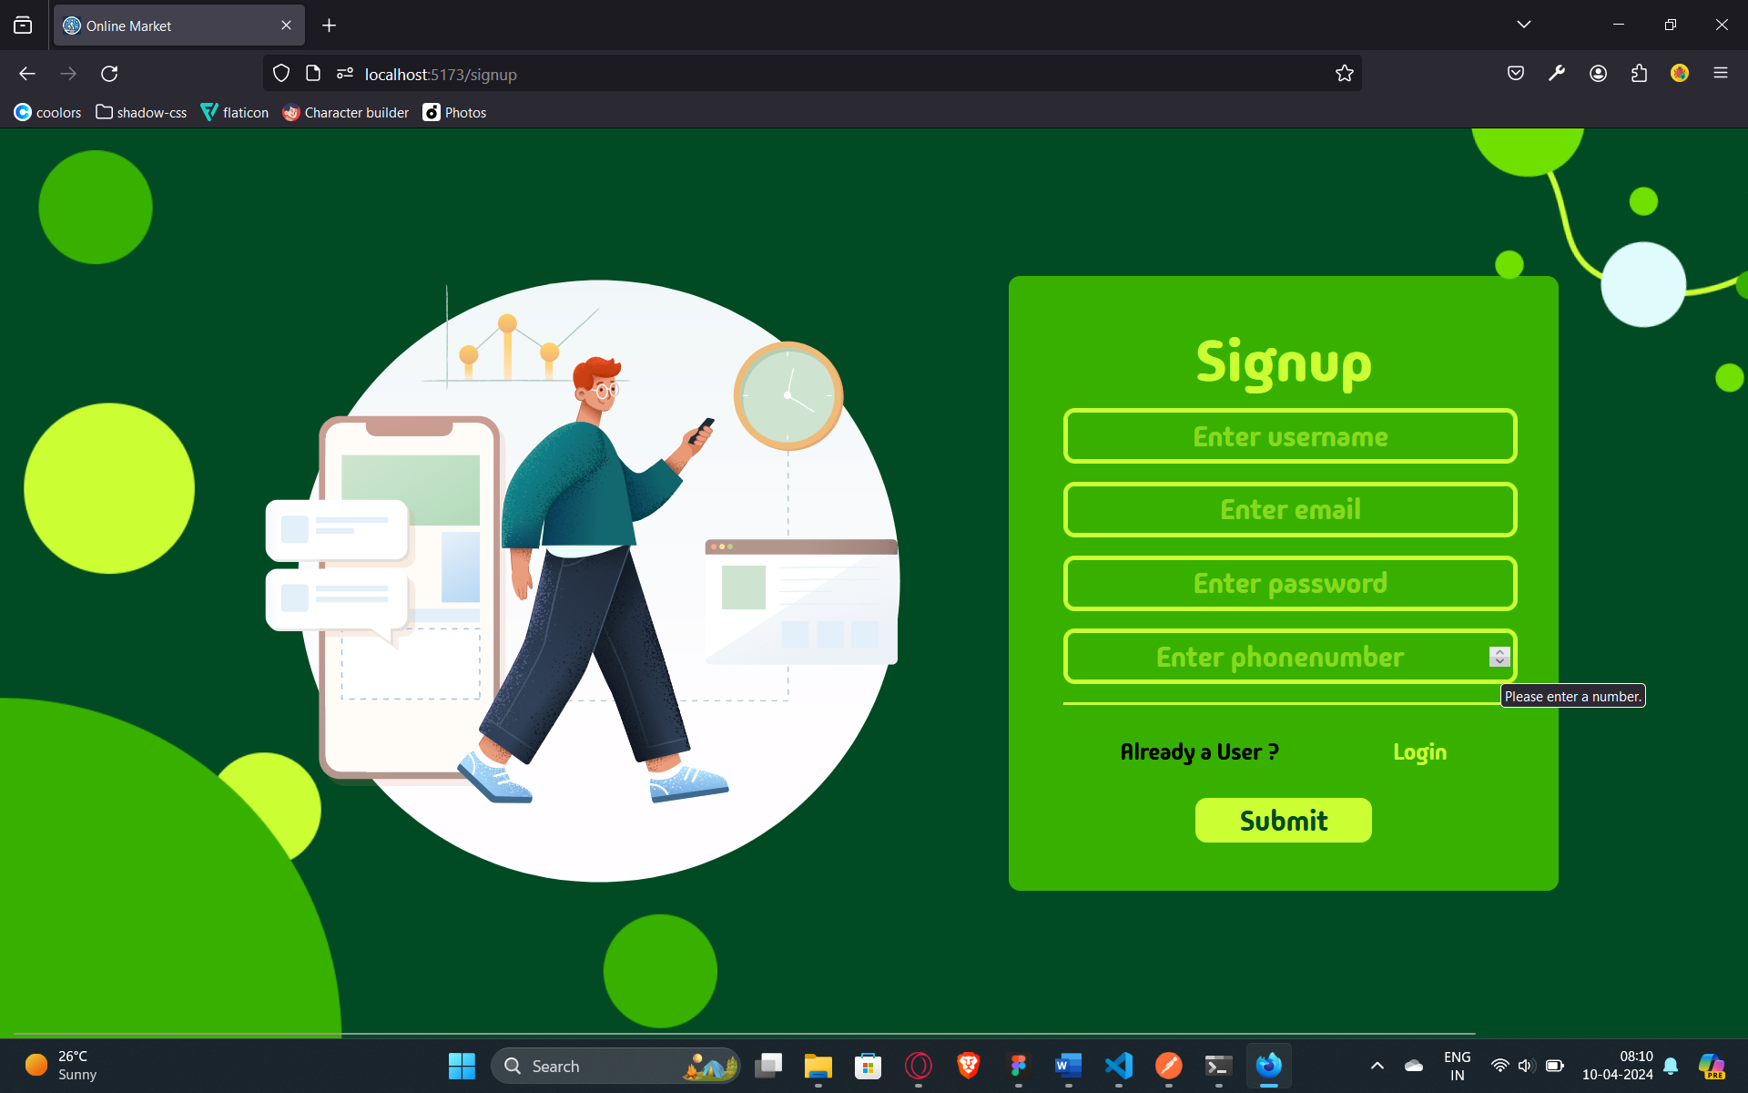

Fig 8: Signup Page

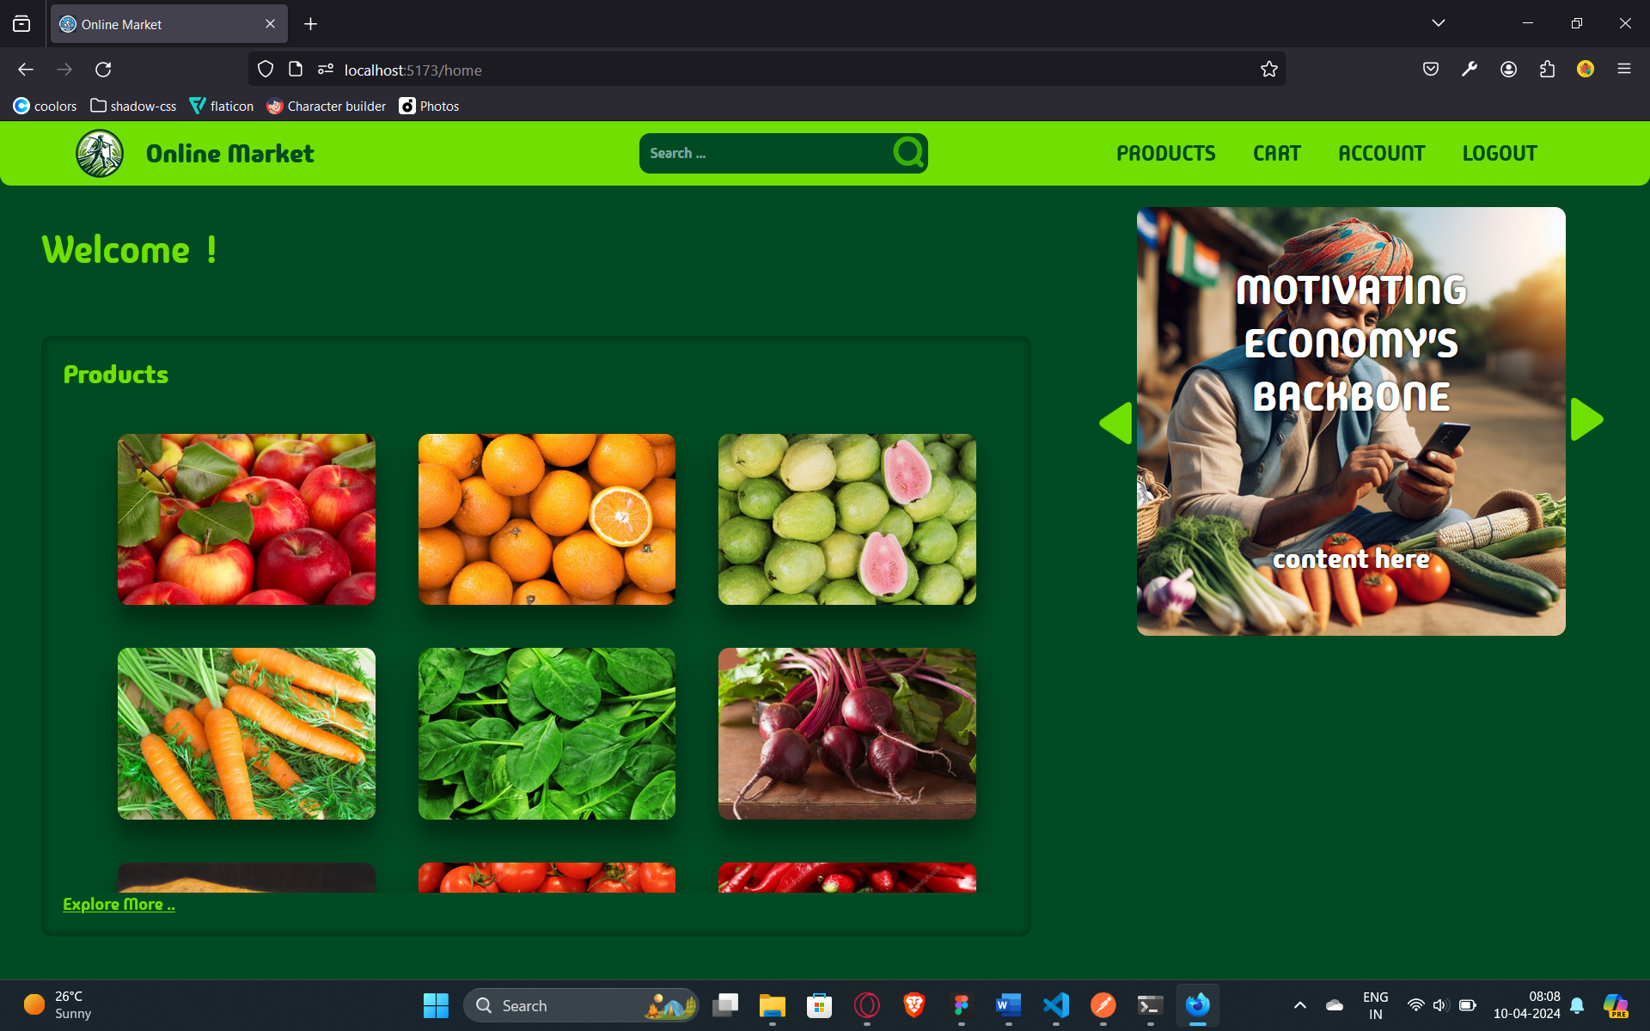

Fig 9: Login page

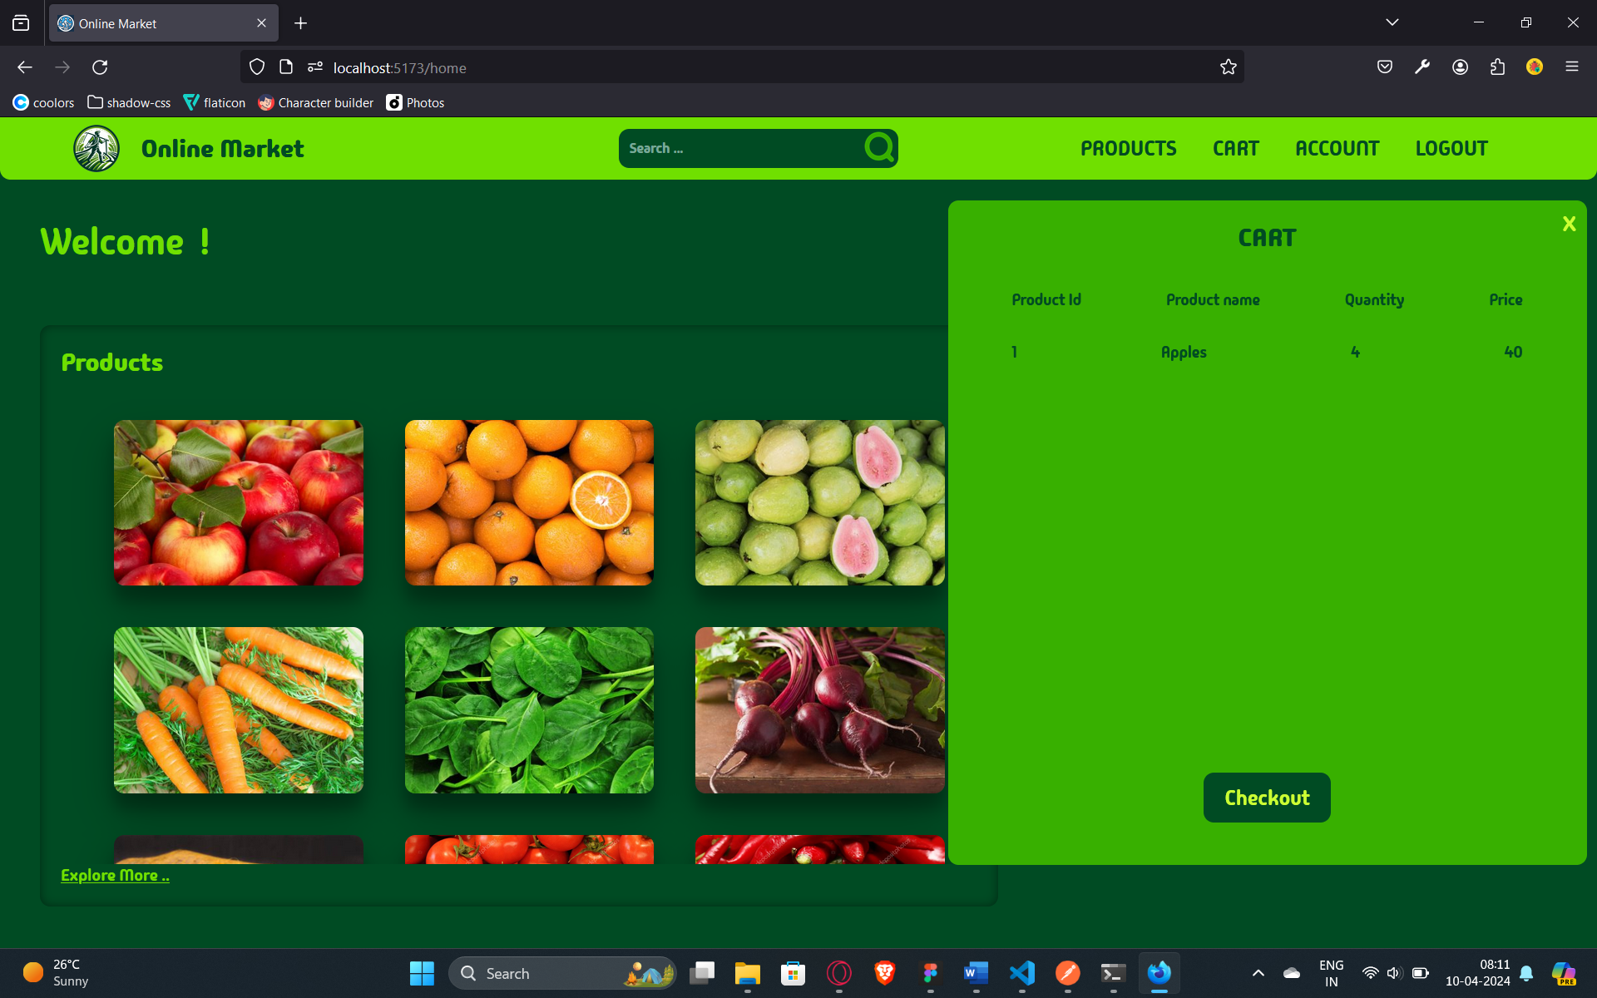

Fig 10: Cart visualization

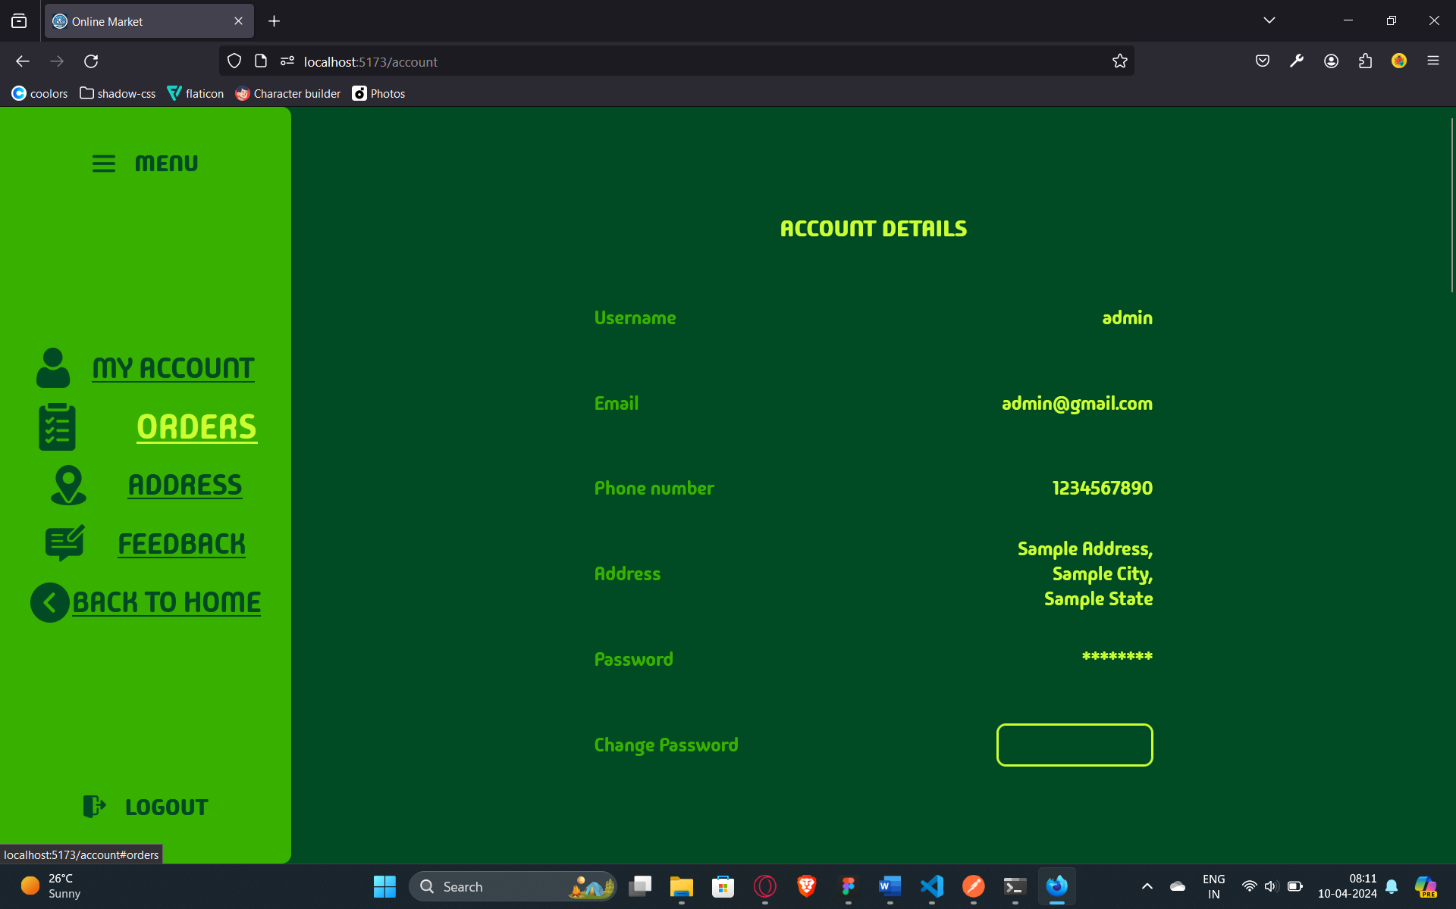

Fig 11: Accounts page

**TEST CASES AND TESTING**

Authentication

1. Login endpoint – /api/v1/login

|  |  |  |  |  |
| --- | --- | --- | --- | --- |
| **Case Type** | **Functionality** | **Description** | **Implementation** | **Testing** |
| Positive | Login | login with valid credential | ✓ | ✓ |
| Negative | LoginWithEmptyCreds | login with credentials as null or empty | ✓ | ✓ |
| Negative | LoginWithWrongUsername | login with non-existing or wrong username | ✓ | ✓ |
| Negative | LoginWithWrongPassword | login with wrong username | ✓ | ✓ |

1. Signup endpoint - /api/v1/register

|  |  |  |  |  |
| --- | --- | --- | --- | --- |
| **Case Type** | **Functionality** | **Description** | **Implementation** | **Testing** |
| Positive | Signup | Signup with valid credentials | ✓ | ✓ |
| Negative | SignupWithEmptyBody | Signup with any or all the value fields as empty | ✓ | ✓ |
| Negative | SignupWithExistingUsername | Signup with username of existing user | ✓ | ✓ |

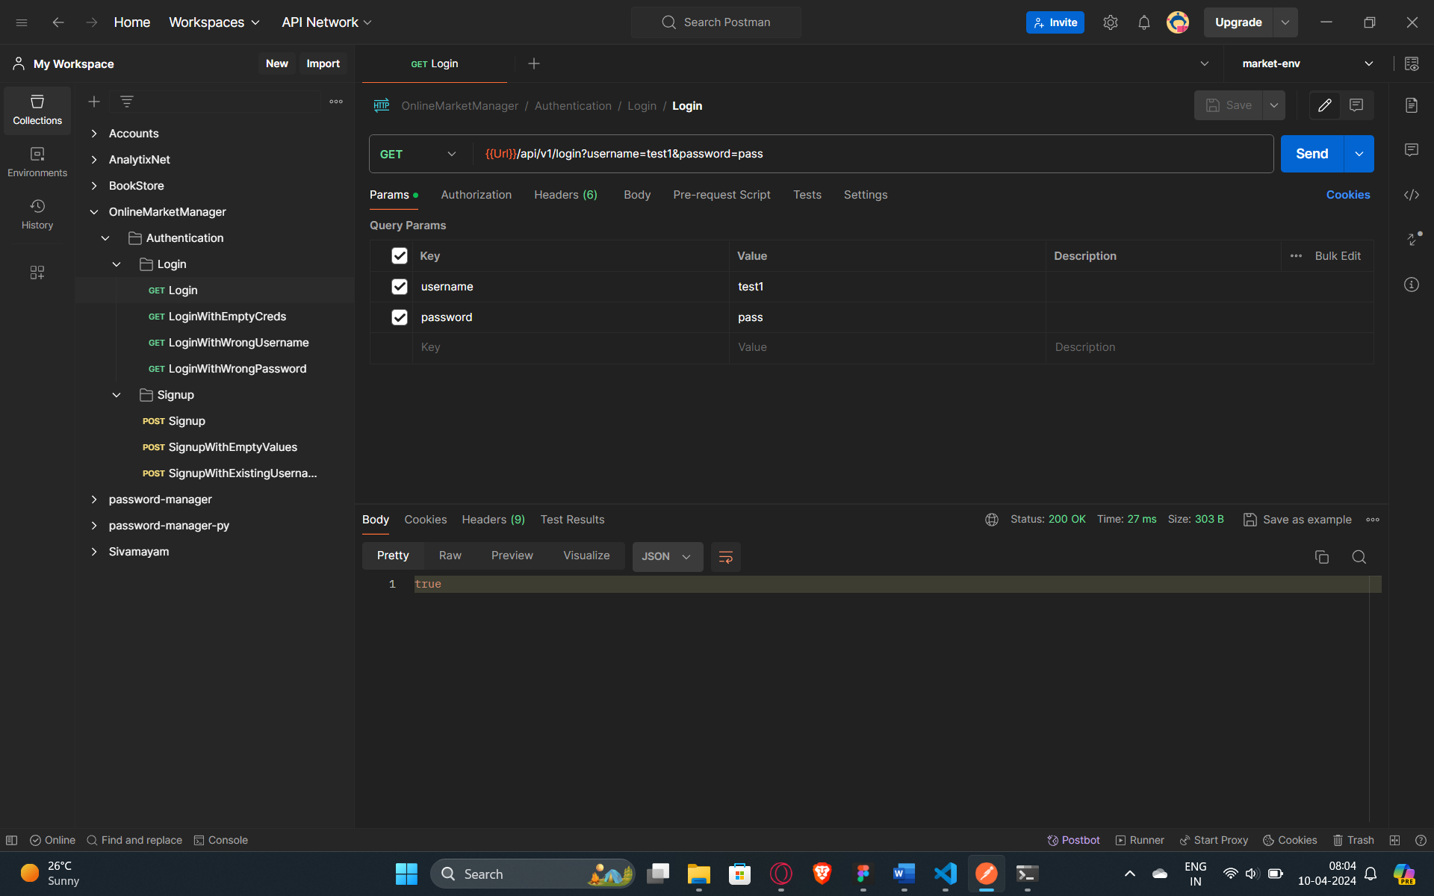

Fig 12: Testing of API in postman

**LINKS**

Figma UI/UX: [Click Here](https://www.figma.com/file/hgpIEtJ5QnTrcmDOvhM4hF/OnlineMarket?type=design&node-id=0%3A1&mode=design&t=q4LyJOiSEWWI2neM-1)

Figma SRS diagrams: [Click Here](https://www.figma.com/file/px8CktVz8ukcIzWOjdHkgH/SRS?type=whiteboard&node-id=0%3A1&t=aFmpaQwcx6n4wqra-1)

GitHub link: [Click Here](https://github.com/AspireCOE/ATHIDYA_U)